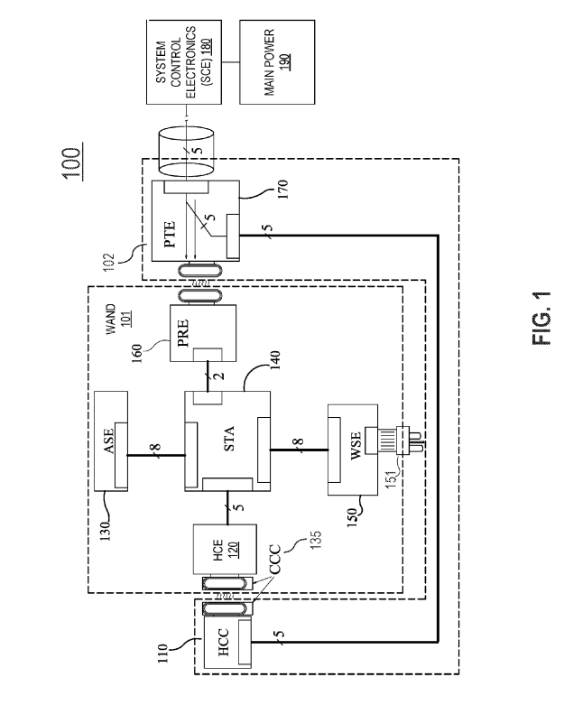

101 = WAND

102 = collar

120 = H-Field Communications Electronics (HCE)

130 = Air Sensor Electronics (ASE)

140 = Station Board (STA)

150 = Water Sensor Electronics (WSE)

160 = Power Receiver Electronics (PRE)

110 = H-Field Communications Collar (HCC)

170 = Power Transmitter Electronics (PTE)

* PTE employs power, ground, and data lines connected to System Control Electronics (SCE)

190 = main power supply

* power supply may be or connect to a line Voltage from a power company and may be transformed or rectified in different ways to power SCE and other Subsystems
* SCE and main power supply may connect to WAND, for example, to communicate information through with or through WAND and collar system
* PTE in an exemplary implementation provides power to PRE, which may be inside a housing of WAND, and PRE distributes power within WAND to HCE, ASE, STA, and WSE

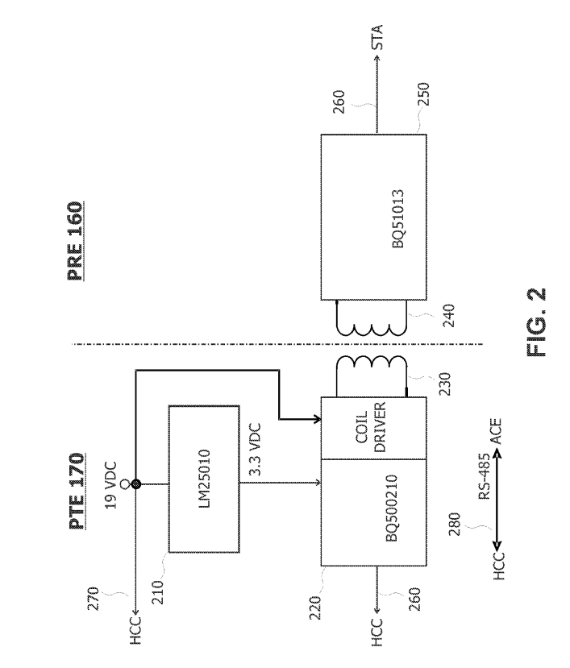

210 = regulator

* receives 19 VDC from an external supply
* provides a 3.3 VDC output to power a manager

220 = manager (eg Texas Instruments P/N BQ500210 “Qi Compliant Wireless Power Transmitter Manager )

* provides a pulse width modulation (PWM) drive signal to a high speed coil driver (eg Texas Instruments TPS28225) which in turn drives a transmitting coil

230 = Wurth Wireless Power Charging Transmitter Coil

* Uses 19-VDC supply
* In the proximity of a receiving coil

240 = receiving coil (eg TDK P/NWR-483250)

* electrically connected to a Texas Instruments BQ51013 Wireless Power Receiver

250 = Texas Instruments BQ51013 Wireless Power Receiver

* 5.0 VDC output of the power receiver may be provided to STA 140 on a line 260

5.0-VDC power received by STA 140 from PRE 160 on line 260 is further provided directly to the HCE 120 on a line 343, WSE 150 on a line 342, and ASE 130 on a line 341. 5.0 VDC power is converted to 3.3 VDC and provided to a Wi-Fi unit

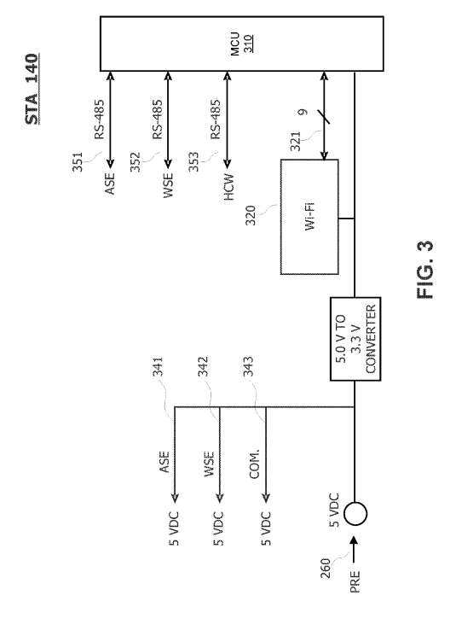

320 = Wi-fi unit (eg a Microchip MRF24WGOMA)

* responds to data and commands provided by a microcontroller unit

310 = microcontroller unit (eg Microchip PIC32MX695F512L)

STA 140 may also include RS-485 communications capability between MCU 310 and ASE 130 on a bus 351, WSE 150 on a line 352, and HCE 120 on a line 353.

**ASE**

* STA 140 may connect to ASE 130, which may support a Suite of sensors for sensing characteristics of the environment of a growing plant. In addition to power and ground on line 341, STA140 may have an RS-484 communications for wire, two-way communication with ASE 130 via bus 351.
* sensors that measure concentrations of CO, CO. and O in the atmosphere around a plant and sensors that measure characteristics of the ambient light in the environment.

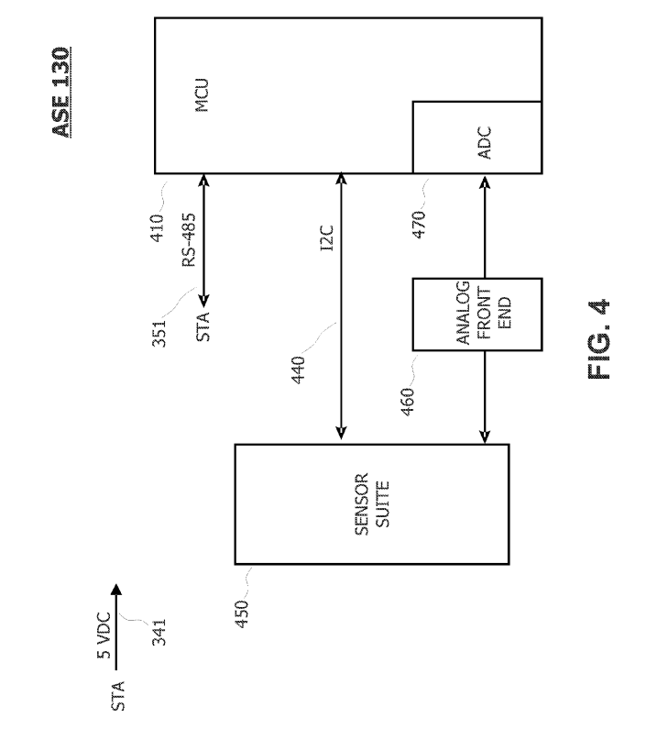

* ASE 130 may include an MCU 410, for example, a PIC32MX350F256H microcontroller, wherein MCU 410 includes an analog-to-digital converter (ADC) 470
* MCU 410 may manage the sensors, for example powering them up or down, placing one or more sensors in standby or operative mode, determining the status of one or more sensors, or performing diagnostics on one or more sensors.
* MCU 410 may also be programmed to receive requests for data related to a given sensor and to provide the data back to STA board 140 via the RS-485 bus 420
* STA 140 may then provide the data to the requester via the Wi-Fi unit 320 or another data link.

**WSE**

* Principle of working identical to ASE 130
* Examples of sensors include any c combination of pH sensors, temperature sensors, total dissolved solids (TDS) sensors, sensors of specific chemicals, resistivity sensors, and any other sensors useful for sensing one or more characteristics a nutrient Solution in a hydroponic system

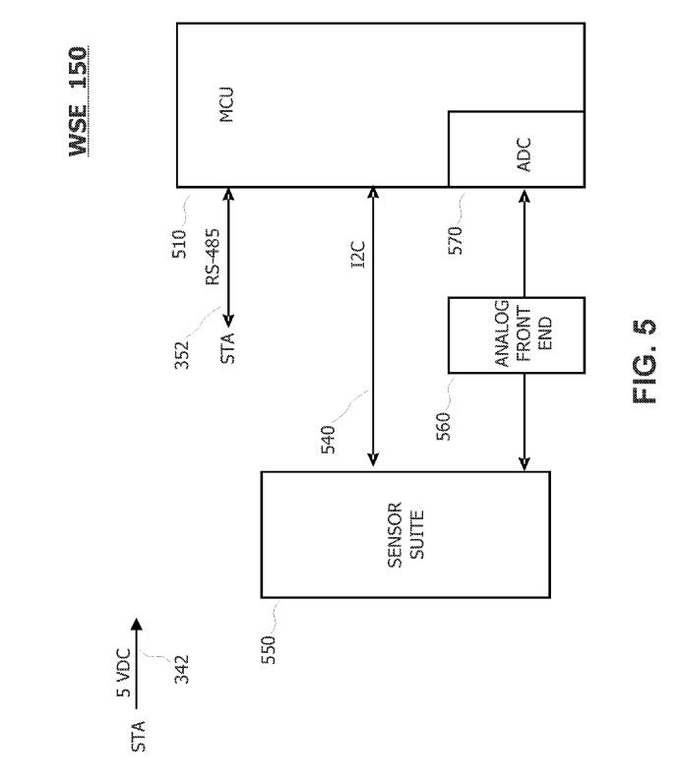

**HCE**

* HCE 120 and HCC 110 operate in a similar fashion to PTE 170 and PRE 160, except data is exchanged between the transmitting and receiving coil rather than power.

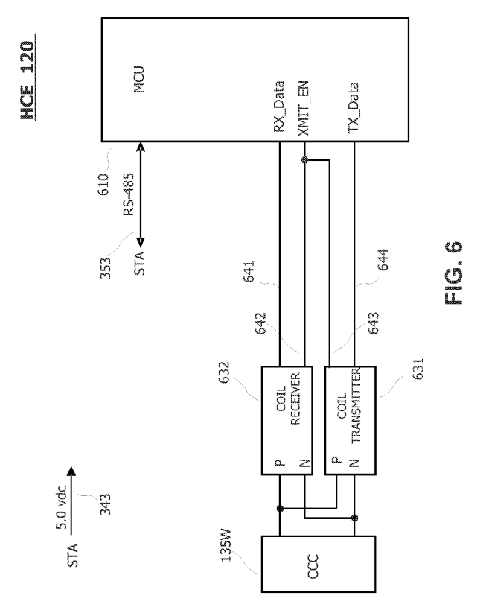

* MCU 610, for example, a Micro chip PIC32MX350F128D, may communicate with STA 140 via the RS-485 bus 353.
* MCU 610 receives data on a line 641 and sends data on a line 644.
* Data activity is controlled by an enable signal XMIT EN on a line 642, 643.
* signals connect MCU 610 to a coil transmitter 631 and a coil receiver 632.
* P and N signals from the coil transmitter 631 and the coil receiver, connected to drive a coil, e.g., a CCC

CCC 135W coil interacts with a matching (may be identical) coil CCC 135C on HCC 110, the pair of coils being proximate to enable inductively passing data signals when the WAND is inserted for operation.

**HCC**

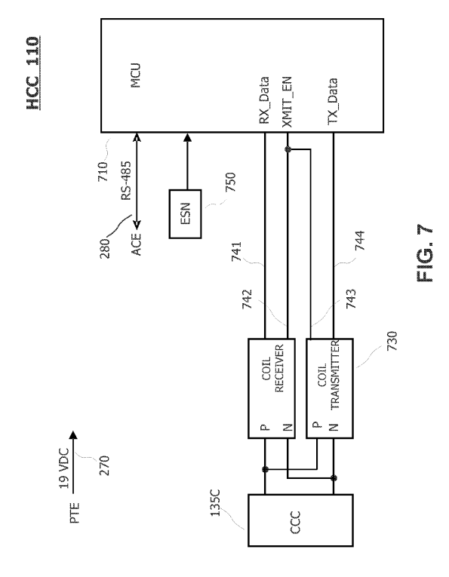

* Similar in working as HCE
* communicate with SCE 180 via the RS-485 bus 280
* HCC 110 includes an ESN (electronic serial number) (eg a Maxim Integrated DS2411)

**SCE**

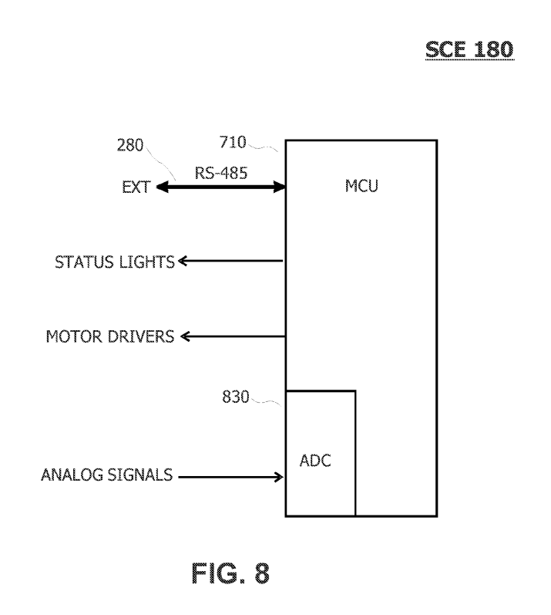

* communicate with WAND 101 via HCC 110 on an RS-485 bus 280
* include an MCU 810, which includes a number of general purpose input/output (GPIO) pins 820.
* include an ADC 830 to provide a digital version of analog signals connected to the ADC 830
* MCU 8.10 may provide signals to turn fans ON or OFF, and turn on a light of an appropriate color

1. Implementation of network station

* includes a microcontroller 1210 that may be programmed for desired communications among sensor modules 1130 and 1150, system control 180, and through a network to a remote device
* controller 1210 may execute software or firmware to collect data points from ASE module 1130, WSE module 1150, or system control electronics 180, to upload the data points to a remote device or cloud database, and to provide system control electronics 180 with the data points or with data, commands, or instructions received from a wireless network.
* Controller 1210 connects to an ASE interface 1230, which may be a chip or other electrical circuit that implements a signaling protocol to transmit or receive communications with ASE module
* ASE interface 1230 may be RS-485 compliant and may connect to ASE module 1130 through a connector 1232

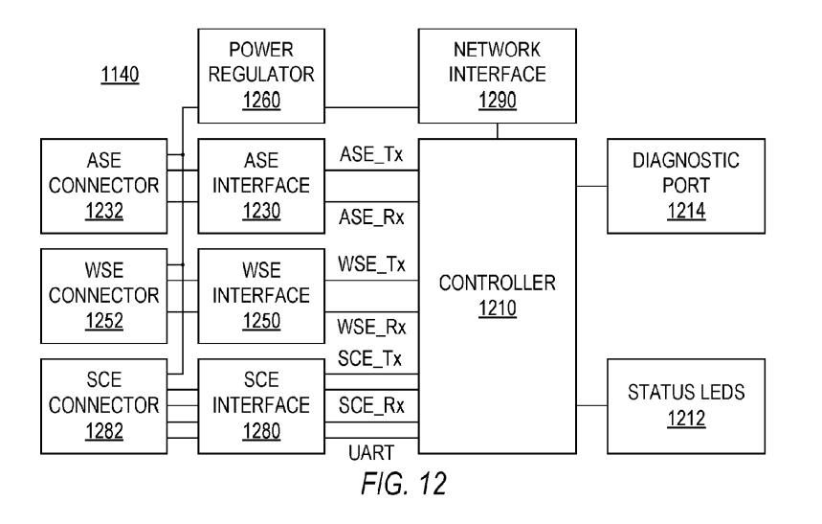

* controller 120 connects to WSE interface 1250 and SCE interface 1280, which respectively allow wired communication with WSE module 1150 and system control electronics 180 through respective connectors 1252 and 1282
* power regulator 1260. which provides power to controller 1210 can also provide power or receive power via connectors 1232, 1252, and 1282 to ASE module, WSE module 1250, and system control electronics
* A network communication interface 1290 may be a chip or electronic circuit that implements a wireless protocol, e.g., Wi-Fi, that enables network device 1140 to communicate through a wireless network

1. Implementation of sensor electronics

* includes a controller 1310 that may be programmable to operate, receive measurements from sensors, and transmit the measurements to network station 1140.
* sensors 1350 may be able to digitally communicate with controller 1310 or may provide analog measurement signals to an analog frontend 1352 that converts the analog signals to digital signals suitable for controller 1310.
* Controller 1310 may communicate information such as sensor measurements to network station 1140 through an interface circuit 1340 such as an RS-485 compliant interface chip connected to network station 1140 through a connector 1242
* power regulator 1360 is used in the implementation to receive power through the connector and to supply regulated power in ASE module 1130.

